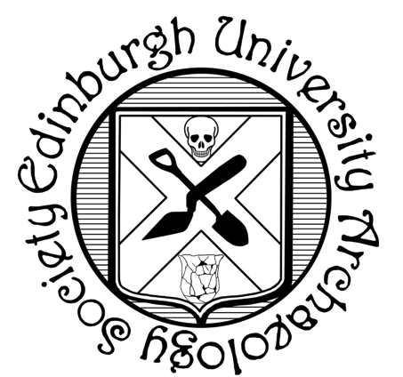

SCOTTISH STUDENT ARCHAEOLOGY SOCIETY CONFERENCE

26/01/19 – 27/01/19

ABSTRACT:

TITLE OF TALK:

**Theme: *‘Scotland’s Diverse Past’***

DEADLINE: **05/01/2019**

Please email all forms to [edin.archsoc@gmail.com](mailto:edin.archsoc@gmail.com)

LEVEL OF STUDY/JOB TITLE:

INSTITUTION:

CONTACT EMAIL:

I would also like to present a poster (please delete one): **YES/NO**

NAME: