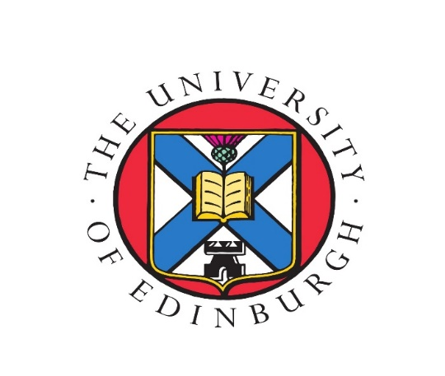

CATASTROPHES AND MEMORY (500-1500 CE)

4TH ANNUAL EDINBURGH INTERNATIONAL
GRADUATE LATE ANTIQUE, ISLAMIC AND BYZANTINE
CONFERENCE (ONLINE)

19th – 21st November 2020

Supported by
THE UNIVERSITY OF EDINBURGH
SCHOOL OF HISTORY, CLASSICS AND ARCHAEOLOGY
LATE ANTIQUE AND BYZANTINE STUDIES RESEARCH GROUP
DEPARTMENT OF ISLAMIC AND MIDDLE EASTERN STUDIES
DEPARTAMENT OF HISTORY OF ART
&
INTERNATIONAL CENTER OF MEDIEVAL ART

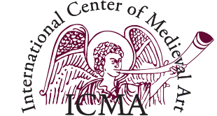

Conference Committee:
B. Adigüzel, N. Alfalasi, K. Defangyu. J. Serrano. S. Slingluff
Description:
This conference will be held online by the Late Antique, Islamic and Byzantine Society of the University of Edinburgh on November 19-21, 2020. The conference focuses on disasters (natural, manmade or “supernatural”) that shape historical memory and our understanding of the past, concentrating on the problematic relations between catastrophes and memory in Late Antique, Islamic and Byzantine societies.

Keynote Speakers:
- Leslie Brubaker is Professor of Byzantine Art History, with particular interest in the cult of the Virgin, ‘iconoclasm’, the relationship between text and image, manuscripts, and gender. She is also Director of the Centre for Byzantine, Ottoman and Modern Greek Studies, which is a unique research cluster with an international reputation, a thriving postgraduate community, and its own journal and two monograph series.

- Antoine Borrut is Associate Professor and Director of Undergraduate Studies in the Department of History at the University of Maryland. He specializes in early Islamic history and historiography and is currently working on two projects: the first focuses on the much-neglected genre of astrological histories and on the role of court astrologers in historical writing in early Islam, the second concentrates on the construction of early Islamic sites of memory and its impact on the making of an agreed upon version of the early Islamic past.

Registration:
A registration fee of £5 will be collected in order to support the continuation of this conference in future years, especially the ability to support the participation of international scholars. This payment will also give you access to discounts at Edinburgh University Press.
Register online: https://www.eventbrite.co.uk/e/laibs-online-conference-late-antiquity-islamic-tickets-117904135443

For any questions, please contact the conference committee: byzantine.pg@ed.ac.uk

Program:
Thursday, 19th November (14:00-18:15 GMT)

14:00-14:10 Opening Remarks: Prof. Niels Gaul (University of Edinburgh)

14:10-15:10 Keynote Speaker: Prof. Leslie Brubaker (University of Birmingham)

15:10-15:20 Break

15:20-16:10 PANEL 1: BIOLOGICAL AND ENVIRONMENTAL CATASTROPHE

“The Disappearing Oasis: The Decline and Fall of the Agricultural Settlements in the Negev Desert During the 7th Century AD”.
Haggai Olshanetsky (PhD Student, Bar-Ilan University)
“The Act of the Natural Miracle and The Language of Madīḥ Nabawī”.
Dr. Lubna Muḥammad I. al-Shanquitiy (Assistant Professor, King Abdul-Aziz University, Jeddah-Saudi Arabia)

16:10-16:20 Break

16:20-18:00 PANEL 2: CONQUEST AND DESTRUCTION

“The Seljuqs/Turks and Byzantium: Conquest, Catastrophe and Memory in East and West: Manzikert (1071), Myriokephalon (1176), and Constantinople (1453)”.
Dr. Songul Mecit (Teaching Fellow, University of Edinburgh)
“For Such Was the Wailing Lamentation of Crete”: Theodosios the Deacon’s Praise of a Massacre during the Conquest of Crete”.
Arie Neuhauser (MPhil LABS program, University of Oxford)
“The Sack of Rome - revised: Quodvultdeus' description of the Vandal Conquest of Carthage”.
Mor Hajbi (PhD Student, Hebrew University of Jerusalem)
“Plague, Crusade, and Black Sea Crisis of the Fourteenth Century”.
Dr. Mike Carr (Lecturer, University of Edinburgh)
Friday, 20th November (13:15-18:00 GMT)

13:15-13:45 Optional Session: “How to get published”: advice for ECRs, Carol Macdonald (Senior Commissioning Editor, Classics & Ancient History) and Nicola Ramsey (Publisher, Islamic & Middle Eastern Studies), Edinburgh University Press.

Welcome words: 14:00-14:10

14:10-15:25 PANEL 3: CIVIL WAR AND URBAN UNREST

“Memory, Mourning and Rituals: The Political Theology of Muharram”.
Dr. Amina Hussain (Assistant Professor, University of Lucknow, India)
“The Nika Revolt between Collective Memory and Classicising Echoes: Narratives from Justinian’s Entourage on the Civil Wars in Byzantium”.
Lucrezia Savoldi (PhD Student, Scuola Normale Superiore of Pisa)
“Ibn Ḥazm’s Experience of Loss after the Destruction of Cordova”.
Dr. Mustafa Muhammad T. BinMayaba (Associate Professor, King Abdul-Aziz University, Jeddah)

15:25-15:40 Break

15:40-16:55 PANEL 4: CATASTROPHE AND THE INDIVIDUAL
“What’s the worst that can happen? The misfortunes of a Byzantine lady”.
Dr. Foteini Spingou (Research Fellow, University of Edinburgh)
“The ʿAbbas after whom those who rule in Baghdad are named”: A source-critical approach to the third fitna (744-750)”.
Leone Pecorini (PhD Student, University of Edinburgh)
“The memory of the Latin conquest of the Byzantine empire in hagiography”
Dr. Alexia-Foteini Stamouli (University of Patras)

16:55-17:10 Break

17:10-18:00 PANEL 5: ARTISTIC CATASTROPHE
“Aniconic Art in Naxos”.
Prof. Jim Crow (Professor of Byzantine Archaeology, University of Edinburgh)
“The Burning Question of Damaged Icons in the Age of Iconoclasm”.
Julian Wood (MPhil student, Oxford)

Saturday, 21st November (14:00-16:45 GMT)
14:00-14:10 Welcome words

14:10-15:25 PANEL 6: ESCHATOLOGY

“The Golden Gate and the Esachatological Significance of the Dome of the Rock.”
Blake Lorenz. (PhD Student, KU Leuven, Belgium)
“Frontiers of Conflict and Patterns of Understanding in the anti-Islamic Texts of Nicetas of Byzantium”.
Dr. Smilen Markov (St. Cyril and St. Methodius University of Veliko Tarnovo)

15:25-15:35 Break

15:35-16:35 Keynote Speaker: Prof. Antoine Borrut (University of Maryland)

16:35-16:45: Closing Remarks

